Project Design Phase-II
Data Flow Diagram & User Stories

Date | 28-06-2025
Team ID | LTVIP2025TMID46195
Project Name | BookNest
Maximum Marks | 4 Marks

Data Flow Diagrams:
A Data Flow Diagram (DFD) illustrates how data flows within the BookNest platform. It shows interactions between users (readers, authors, and admins), system components, and data storage.
Example: DFD Level 0 (Industry Standard)
- Readers can browse, search, and purchase books.
- Authors can upload and manage book listings.
- Admins moderate content and manage platform operations.
- System handles authentication, book listings, reviews, and payment transactions.
- Data Stores include user profiles, book inventory, orders, and messages.
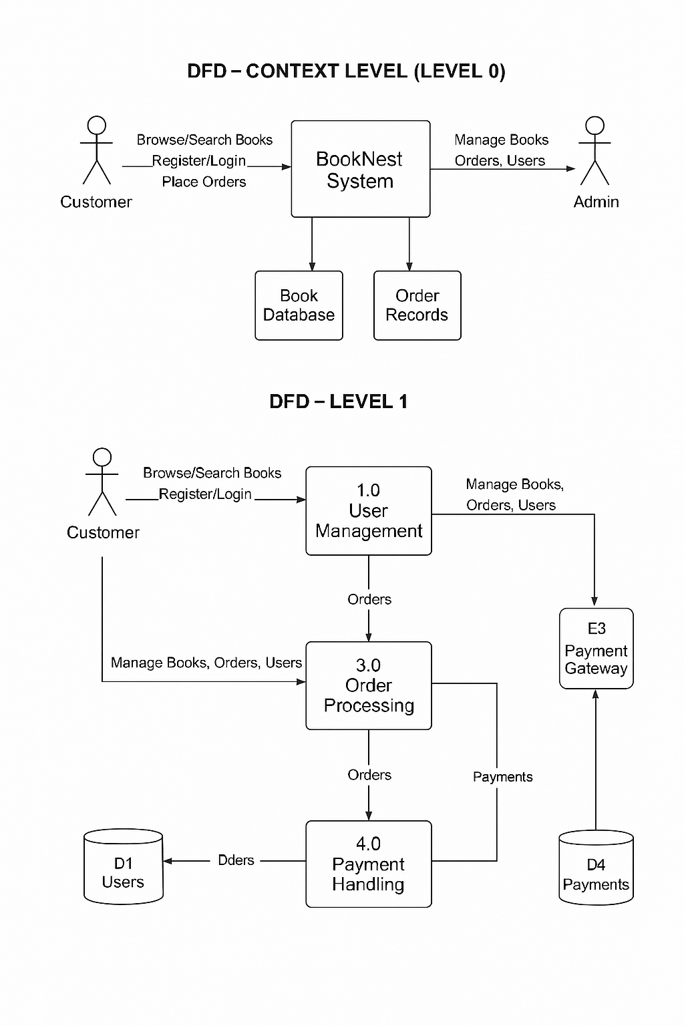

User Stories
User Story Table – BookNest
User Type | Functional Requirement (Epic) | User Story / Task | Acceptance Criteria | Priority | Release
Reader | Book Discovery | As a reader, I can search for books by title, author, or genre. | Search returns relevant book listings. | High | Sprint-1
Reader | Purchase System | As a reader, I can purchase e-books securely. | Payment is processed and download is available. | High | Sprint-2
Author | Book Management | As an author, I can upload and manage my book listings. | Books are visible to readers after submission. | High | Sprint-1
Author | Earnings Dashboard | As an author, I can view sales and earnings reports. | Dashboard displays up-to-date metrics. | Medium | Sprint-2
Admin | Content Moderation | As an admin, I can review and remove inappropriate content or books. | Flagged content is reviewed and actioned. | High | Sprint-1
Reader & Author | Messaging | As a user, I can send and receive messages with other users. | Messages appear instantly and are stored. | Medium | Sprint-2
Reader | Review System | As a reader, I can leave reviews for purchased books. | Reviews appear on the book’s page. | Medium | Sprint-2
Admin | User Management | As an admin, I can deactivate or flag users violating policies. | Actions are logged and users restricted accordingly. | High | Sprint-1

